_{Wilson Tennis Bag}
PRICE: Approximately Rs. 25,000
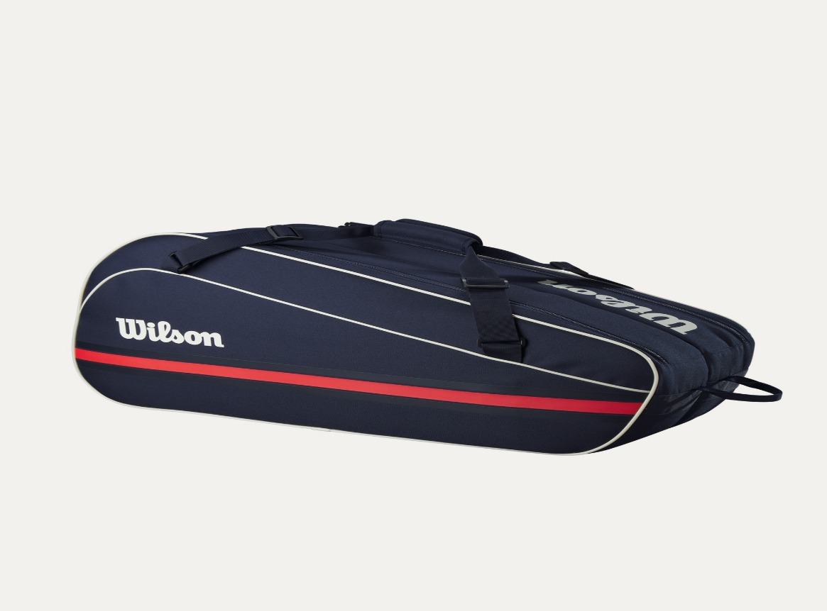

_{Introduction:}

The Wilson Tennis Bag is a practical and stylish solution for carrying tennis gear safely and comfortably. Designed for players who value organization and durability, this bag is perfect for training, matches, and travel.
Product Overview:
The Wilson Tennis Bag offers ample storage space to carry rackets, shoes, balls, and personal items. With its smart compartment design and strong build, it ensures your equipment stays protected and easy to access.

About the Brand:

Wilson is a world-famous sports brand trusted by professional and recreational athletes. Known for premium quality and innovative designs, Wilson tennis bags are made to meet the demands of modern players..
Key Features:
- Spacious main compartments
- Dedicated racket storage section
- Comfortable shoulder straps
- Secure zipper closures
- Lightweight yet durable design

Design & Build Quality:
The bag features a sleek, sporty design with reinforced stitching for long-term use. Its ergonomic structure makes it comfortable to carry, whether on the shoulder or as a backpack.

Storage & Capacity:
The Designed to hold multiple tennis rackets along with accessories such as shoes, towels, water bottles, and tennis balls. Side pockets provide extra space for small personal items.

Material & Durability:
Made from high-quality polyester and reinforced fabric, the Wilson Tennis Bag is resistant to wear and tear, making it suitable for regular use and travel
Ideal For:
- Tennis players of all levels
- Training sessions and tournaments
- Sports academies
- Daily practice and gym use

Care Instructions:
- Clean with a damp cloth when needed
- Avoid overloading the bag
- Store in a dry place
- Keep away from sharp objects

Product Specifications:
- Brand: Wilson
- Product Type: Tennis Bag
- Material: Durable polyester fabric
- Carry Style: Shoulder bag/bagpack
- Compartments: Multiple
- Usage: Training & Match use

Product Summary:
The Wilson Tennis Bag combines functionality, comfort, and durability in one premium package. It is an ideal choice for players who want organized storage and reliable protection for their tennis equipment..

